Code:
library IEEE;
use IEEE.STD_LOGIC_1164.ALL;
use IEEE.STD_LOGIC_ARITH.ALL;
use IEEE.STD_LOGIC_UNSIGNED.ALL;
entity shiftregister is
Port ( clk : in STD_LOGIC;
reset : in STD_LOGIC;
datain : in STD_LOGIC_VECTOR (3 downto 0);
sel : in STD_LOGIC_VECTOR (1 downto 0);
sl_in : in STD_LOGIC;
sr_in : in STD_LOGIC;
dataout : out STD_LOGIC_VECTOR (3 downto 0));
end shiftregister;

architecture Behavioral of shiftregister is

begin
process(reset, clk, sel, sl_in, sr_in, datain)
variable TEMP : STD_LOGIC_VECTOR (3 downto 0);

begin
if reset = '1' then
TEMP := "0000";

elsif clk'event and clk = '1' then
case Sel is
when "11" => TEMP := datain;
when "01" => TEMP := TEMP(2 downto 0) & sl_in;
when "10" => TEMP := sr_in & TEMP(3 downto 1);
when others => NULL;
end case;
end if;
dataout <= TEMP;
end process;

end Behavioral;

RTL Diagram :

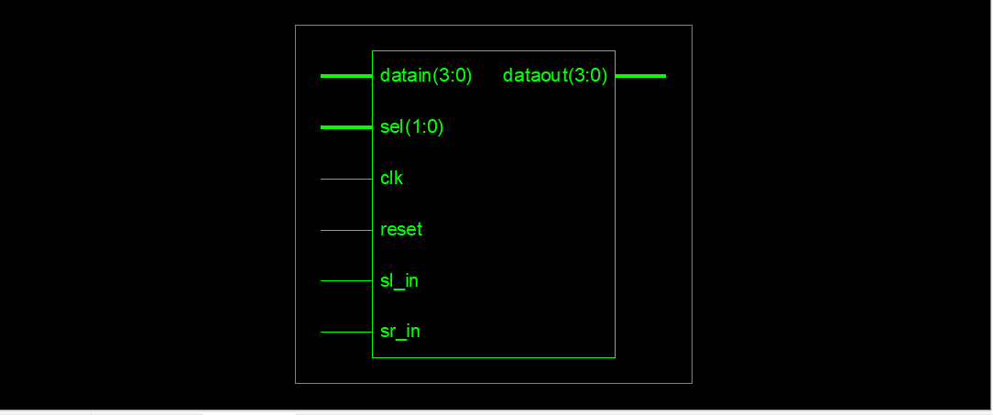

Output :
Left Shift :
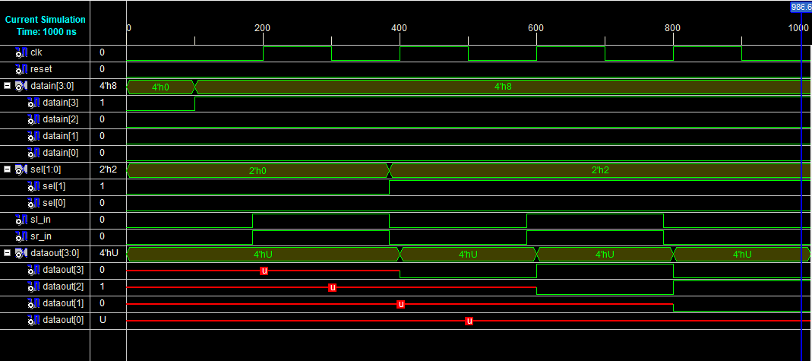

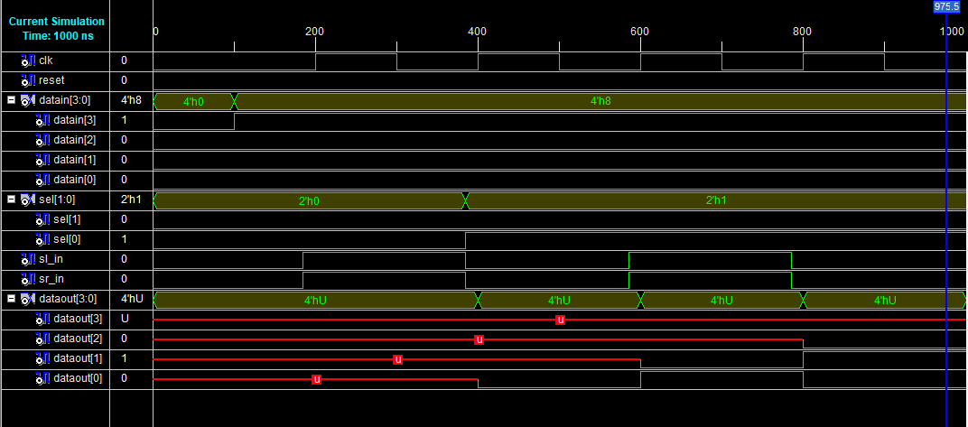
Right Shift :

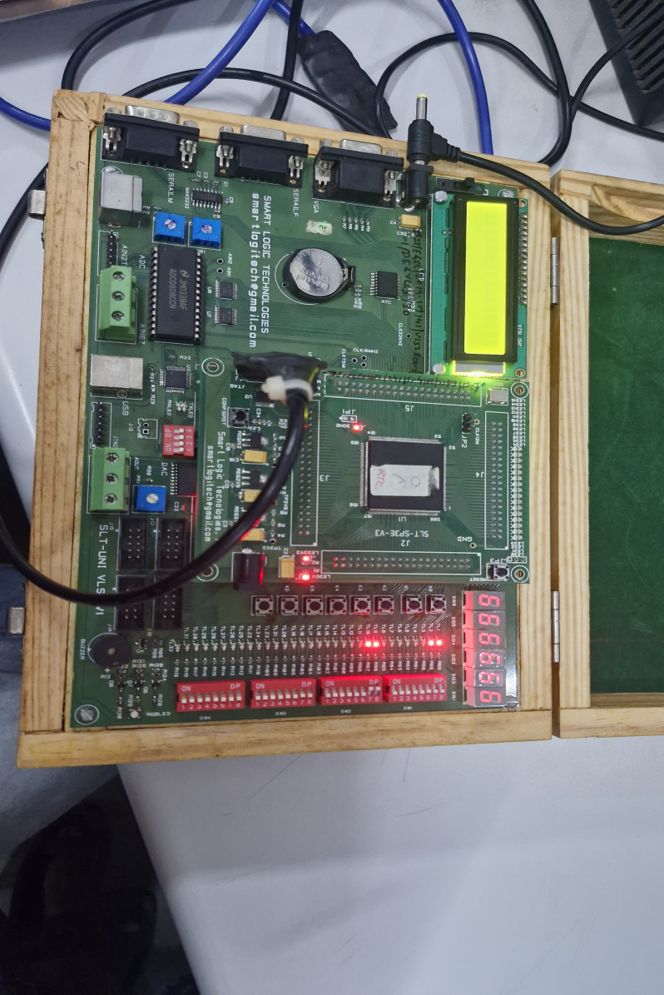
Hardware Output :

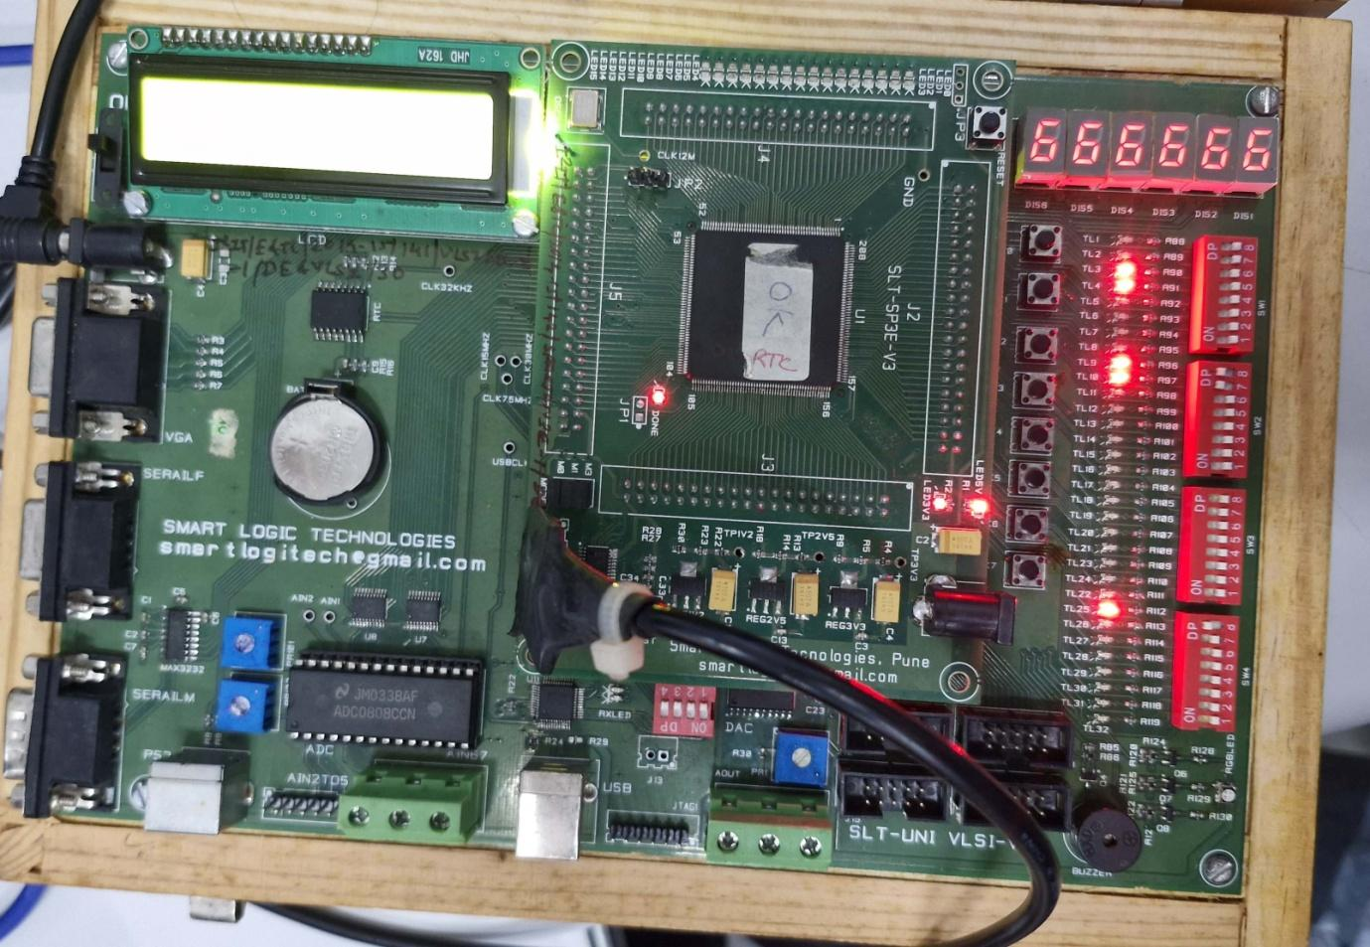

Pin Assignment :
Sr. No. | Signal Name | Pin Designation | Direction | FPGA Pin No.
1 | clk | Clock 555: 1Hz | Input | P132
2 | reset | Key0 | Input | P204
3 | dataout[0] | TL1 | Output | P205
4 | dataout[0] | TL2 | Output | P206
5 | dataout[0] | TL3 | Output | P203
6 | dataout[0] | TL4 | Output | P200
7 | datain[0] | TL9 | Input | P192
8 | datain[1] | TL10 | Input | P193
9 | datain[2] | TL11 | Input | P189
10 | datain[3] | TL12 | Input | P190
11 | SL_in | TL17 | Input | P179
12 | SR_in | TL18 | Input | P180
13 | sel[0] | TL25 | Input | P165
14 | sel[1] | TL26 | Input | P167

